1. Write the HTML code using css to create a webpage that looks like the screenshot below. Follow these steps:

• Create a div for the paragraphs and style it appropriately.

• Create a span for the first sentence of each paragraph, and style appropriately.

• Resize the image to match the width of the div.

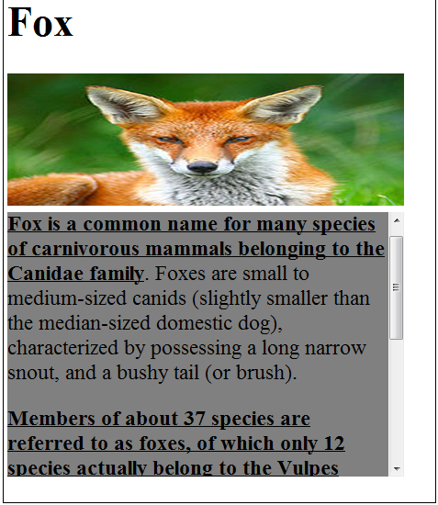

1. Write the HTML code using css to create a webpage that looks like the screenshot below.

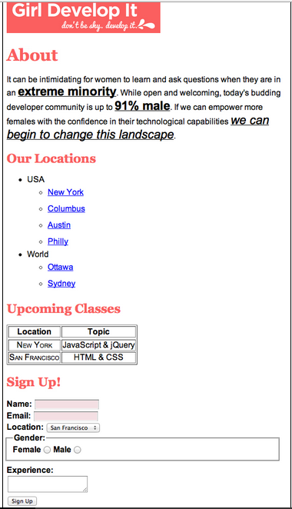

3.Write Java Script to generate multiplication table taking input from user

4.Write javaScript to take two input numbers from the user and display the sum,difference,product and division of two numbers.